**EYFS Newsletter**

**Classes 1 & 2**

Welcome to EYFS and the start of a brand new school year. This is a very exciting and nervous time for both you and your child so if you have and queries or concerns please feel free to come and have a chat with myself or Mrs Duckworth. You can also contact us via seesaw. Other adults working with us in classes 1 and 2 are Miss Hatton, Mrs Iley and Mrs Horrocks. Please feel free to talk with any member of the EYFS team if you have a query or concern.

You can contact myself or Mrs Duckworth via seesaw or parents@fulwoodandcadley.lancs.sch.uk

NUT ALLERGY. We have a number of children in school with nut allergies, therefore no products containing nuts are allowed in school

**In a morning!!!!**

Initially myself, Mrs Duckworth, Ms Hatton, Mrs Iley and Mrs Horrocks will be there to greet the children in a morning on the playground. Once the children become more settled and used to our morning routine, they will enter the school themselves with the other children through the gate off the field and through class 3. We feel that it is important for the children to have a calm and happy start to their day. Unfortunately, this is not always the case and even the smallest things like not having the correct cereal in or not having hair done how they want can cause a huge amount of stress in a morning. No matter how small you feel the issue is please let us know because this can determine how your child starts the day and therefore we can address these issues straight away in class. If we are not at the door in a morning please pop us a message on seesaw.

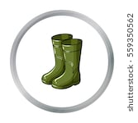

**IMPORTANT!!!!!!!!!**

* Your child must have a pair of wellies with their name in them. They need these to access certain areas of learning in our outdoor area and for lunchtimes.
* All jumpers, cardigans, t shirts, skirts, trousers, SHOES, coats, pinafores must named.
* Please send your child with a coat every day no matter what the weather is.
* Please bring a named water bottle in each day.
* Please send in a named toothbrush for your child as part of our healthy lives in PSED lessons.

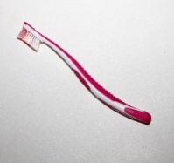



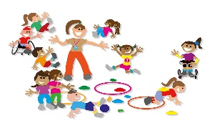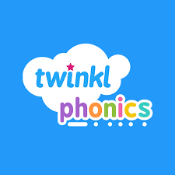**Phonics:** We follow the Twinkl scheme of work for phonics. The children will take part in phonics lessons each day. The sounds and tricky words will be sent home weekly for you to practise at home. Please practise these sounds as words as much as possible.

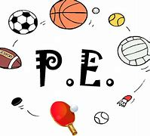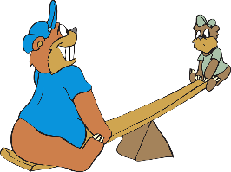

**Please help!!!!**

The children love our workshop area and it is amazing to see what they create. In order to keep our workshop fully stocked please could you send in small boxes, milk bottle tops (plastic or foil), yoghurt pots, small bottles, toilet/kitchen rolls. Anything that can be recycled we will have.

**PLEASE NOTHING THAT HAS BEEN IN CONTACT WITH NUTS**

**PE Days**

Class 1: Tuesday and Thursday

Class 2: Thursday and Friday

All children are to come into school in their PE kits on these day. Please ensure the children are wearing trainers and all PE kit is named.

**Seesaw**

We use Seesaw in class to record the children’s learning through the continuous provision areas and enhancements we set up. You have received a code to log into your child’s Seesaw page. **You will only have access to your own child.** Please look at Seesaw with your child and talk about what they have been doing. If your child does something at home linked to our learning in class you can also upload pictures for us to see. We love discussing home experiences with the children.

[](http://www.google.co.uk/url?sa=i&rct=j&q=&esrc=s&source=images&cd=&cad=rja&uact=8&ved=0ahUKEwjGjMac1OPVAhUGvBQKHUHzD-QQjRwIBw&url=http://www.clipartpanda.com/categories/book-worm-clip-art&psig=AFQjCNFSc6T7NbUJ--L2Ok0vo52hLWRxpg&ust=1503244476851964)Our parent opening evening for both classes is Thursday 19th September at 3.30pm. Please come a find out all about your child’s time in classes 1 and 2.

This half terms topic is………… **All About Me and Bears,**

We will be spending the first half term getting to know all about each other. We will be talking about who is in our family, the different types of family and what our house is like. We will also be thinking about what we like and don’t like and what we are good at and find tricky. We will also be talking about our feelings and how we are different. We will be linking our topic of family to bears and reading a number of stories that focus on bear families and the home. These include: Goldilocks, We’re going on a Bear hunt, Brown Bear, Brown Bear, Peace at Last and Bumble Bear.

**Reading**

Reading books will be coming home with your child in the next few weeks. They are wordless at first to encourage your child to look at the pictures and use their imagination to create their own stories. Once your child has begun to successfully blend sounds together during our phonic lessons they will move on to books with words. Please read as much as you can with your child. I am fully aware everyone has busy lives but the more your child practises reading at home the more progress they will make in all areas of their development. Please sign the reading record every time you read with your child.

**If you have any issues let us know and we can help!!!!**

**We go outside no matter the weather and although we have suits and wellies the children can still sometimes get wet, especially feet and bottoms. It would be helpful if you could keep a spare pair of socks and underwear in your child’s bag. We will send home any wet clothes so you can replace them ASAP.**

**Helping at home**

**In class we encourage the children to be as independent as possible. This includes putting their coats on themselves, taking off and putting on jumpers and cardigans and taking off their shoes and socks for PE and putting them back on. Please practise these skills at home as much as possible.**

**Also the children need to be able recognise their own name so they can hang up their coats on bags on their pegs.**

Finally…….

We would like to thank you in advance for your support over the next term. We all have very busy lives but the more you interact with your child through play, cuddles, talking, reading the more progress they will make in **all areas of their development**. If you have any issues, concerns or worries let us know and we can help!!!!

Mrs True, Mrs Duckworth, Mys Iley and Miss Hatton