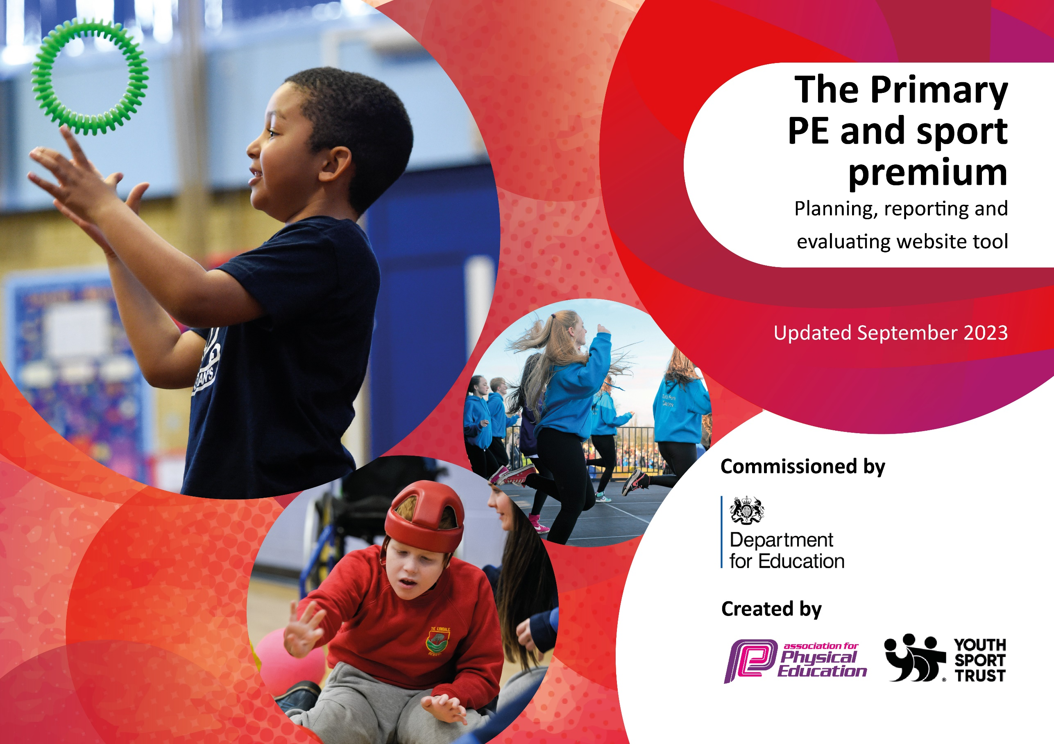

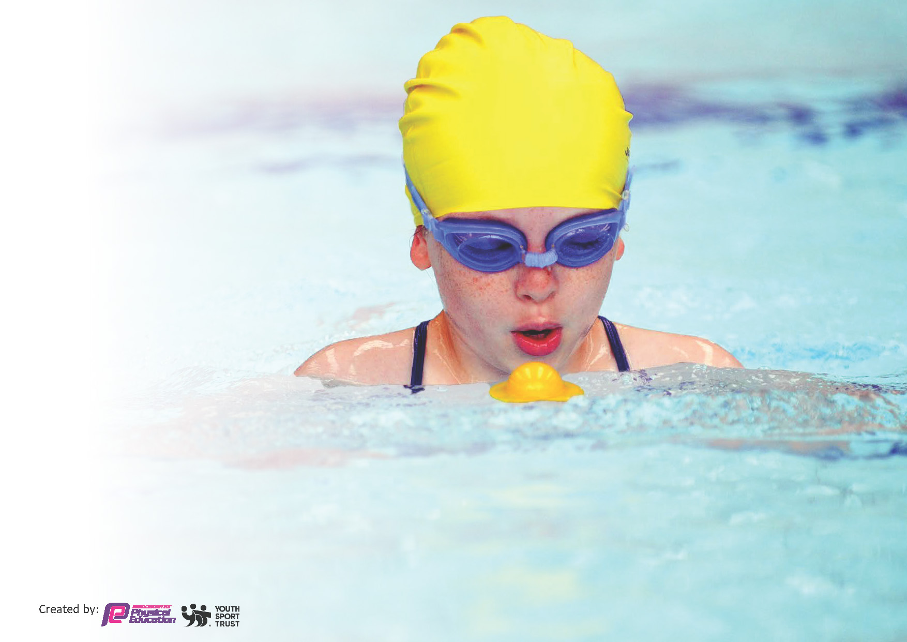
This template can be used for multiple purposes:
by:
- It enables schools to effectively plan their use of the Primary PE and sport premium
- It helps schools to meet the requirements (as set out in guidance) to publish information on their Primary PE and sport premium
- It will be an effective document to support Ofsted inspections enabling schools to evidence progress in Physical Education (PE) and evidence swimming attainment, which forms part of the PE National Curriculum. We would recommend schools consider
the Intent, Implementation and Impact of any spend, as examined within the Education Inspection Framework.

It is important that your grant is used effectively and based on school need.

Schools must use the funding to make additional and sustainable
improvements to the quality of the PE, School Sport and Physical Activity (PESSPA)
they offer. This means that you should use the Primary PE and sport premium to:

- Build capacity and capability within the school to ensure that improvements made now will benefit pupils joining the school in future years
- Develop or add to the PESSPA activities that your school already offers.

The Primary PE and sport premium should not be used to fund capital spend projects; the school’s core budget should fund these. Further detail on capital expenditure can be found in the updated Primary PE and sport premium guidance.

The Primary PE and sport premium guidance, outlines 5 key priorities that funding should be used towards. It is not

necessary that spending has to meet all the key priorities, you should select the priorities that you aim to use any funding towards.

Although completing this template is not a requirement for schools, schools are required to publish details of how they spend this funding. Schools must also outline what the impact this funding has had on pupils’ PE and sport participation and attainment and how any spending will be sustainable in the future. All funding must be spent by 31st July 2024.

The Department for Education has worked closely with the Association for Physical Education (afPE) and the Youth Sport Trust (YST) to develop this template and encourages schools to use it. This template is an effective way of meeting the reporting requirements of the Primary PE and sport premium.
Review of last year’s spend and key achievements (2022/2023)

We recommend you start by reflecting on the impact of current provision and reviewing your previous spend.

Activity/Action | Impact | Comments

Key priorities and Planning
This planning template will allow schools to accurately plan their spending.

Action – what are you planning to do | Who does this action impact? | Key indicator to meet | Impacts and how sustainability will be achieved? | Cost linked to the action
CPD for teachers and TA’s who deliver PE curriculum sessions:  - Identify key areas for development from staff questionnaire  - Deliver 2 x staff training in Spring term focusing on identified areas.  - Team teach schedule in place for least confident staff – Cl1-5 ST & Cl 6-11 KLF | Primary generalist teachers and TA’s who cover PPA | Key Indicator 1: Increased confidence, knowledge, and skills of all staff in teaching PE and sport. | Primary teachers more confident to deliver effective PE supporting pupils to undertake extra activities inside and outside of school, including teaching water safety and swimming and as a result improved % of pupil’s at EXS + attainment in PE.  This provision can be sustained due to in house expertise being deployed for CPD. Cover will be managed regardless of funding through other TA support. | Time:  PE leader release for full day to plan 2 x staff training sessions.  PE leader and HT released to team teach ½ day per week for 2 x terms.
Varied extra-curricular offer to engage all children including vulnerable and target group: girls, in physical activity and sport. | All pupils | Key Indicator 2: increasing engagement of all pupils in regular physical activity and sport  Key indicator 4: offer a broader and more equal experience of a range of sports and physical activities to all pupils  Key indicator 5: increase participation in competitive sport | Pupil engagement in all types of physical activity will increase impacting positively on mental and physical health.  The offer of a more varied sports experience will motivate dis-engaged pupils and increase their participation. | Judo/ Fencing/Archery  £1800
Engage all pupils and staff in Outdoor Adventure Activities, securing links with other subject areas such as Geography.  Staff training on PE/Geog linked learning.  Cl 3-11 to attend Borwick Hall for an adventure day to launch the provision  Curriculum units throughout the year include 2 OAA KS2 and 1 in KS1.  Enhance teacher subject knowledge in the effective deliver of this area of PE.  Engage chd in a different kind of activity, supporting both their mental and physical health. | Pupils and staff | Key Indicator 1: Increased confidence, knowledge, and skills of all staff in teaching PE and sport.  Key Indicator 2: increasing engagement of all pupils in regular physical activity and sport  Key Indicator: raising the profile of PE and sport across the school, to support whole school improvement  Key indicator 4: offer a broader and more equal experience of a range of sports and physical activities to all pupils | Teachers develop expertise and professional development to enhance provision in curriculum lessons within school. Improvement in the attainment and progress in OAA.  Engage pupils in alternative physical activity with the aim of sustaining engagement. | £10,000 Borwick Hall
Increase the number of children accessing swimming from Summer term.  Curriculum Swimming – School Budget  Year 5 to attend curriculum swimming Aut which was initiated Summer 2023.  From Spring term Y4 to attend  Top Up Summer term Y4/5/6 non-swimmers.  Sep 2024 Y4 (school budget) and Y3 (PE budget) attending swimming lessons simultaneously | Pupils | Key Indicator 1: Increased confidence, knowledge, and skills of all staff in teaching PE and sport.  Key Indicator 2: increasing engagement of all pupils in regular physical activity and sport |  | £2940.00

Key achievements 2023-2024
This template will be completed at the end of the academic year and will showcase the key achievements schools have made with their Primary PE and sport premium spending.

Activity/Action | Impact | Comments

Swimming Data
Meeting National Curriculum requirements for swimming and water safety.
Priority should always be given to ensuring that pupils can perform safe self-rescue even if they do not fully meet the first two requirements of the National Curriculum programme of study

Question | Stats: | Further context  Relative to local challenges
What percentage of your current Year 6 cohort can swim competently, confidently and proficiently over a distance of at least 25 metres? | % | Use this text box to give further context behind the percentage.  e.g., 30% - we are struggling to get pool space due to our local pool closing so we have had to use a much smaller local school pool. We have had to limit the number of pupils attending swimming lessons during one term which means some pupils have attended fewer swimming lessons than others.
What percentage of your current Year 6 cohort can use a range of strokes effectively [for example, front crawl, backstroke, and breaststroke]? | % | Use this text box to give further context behind the percentage.  e.g., Even though your pupils may swim in another year please report on their attainment on leaving primary school at the end of the summer term 2024

What percentage of your current Year 6 cohort are able to perform safe self-rescue in different water-based situations? | % | Use this text box to give further context behind the percentage.
If your schools swimming data is below national expectation, you can choose to use the Primary PE and sport premium to provide additional top-up sessions for those pupils that did not meet National Curriculum  requirements after the completion of core lessons. Have you done this? | Yes/No
Have you provided CPD to improve the knowledge and confidence of staff to be able to teach swimming and water safety? | Yes/No

Signed off by:

Head Teacher: | Kirsty France
Subject Leader or the individual responsible for the Primary PE and sport premium: | Sarah True PE Leader
Governor: | Jo Margerison
Date: | 5th Oct 2023

