Fulwood and Cadley Primary School



Behaviour Policy

October 2023

|  |  |  |  |
| --- | --- | --- | --- |
| Signed by: | | | |
|  | Headteacher | Date: |  |
|  | Chair of governors | Date: |  |

Last updated: October 2023

**Contents:**

Statement of intent

1. Legal framework
2. Roles and responsibilities
3. Definitions
4. Staff induction, development and support
5. Social, emotional and mental health needs (SEMH)
6. Managing behaviour
7. Prevention strategies, interventions, and consequences for unacceptable behaviour
8. Sexual abuse and discrimination
9. Child on Child Abuse
10. Sexual abuse & discrimination
11. Smoking & controlled substances
12. Prohibited items, searching pupils and confiscation
13. Effective classroom management
14. Behaviour outside of school premises
15. Data collection and behaviour evaluation
16. Monitoring and review

**Appendices**

1. Consequences
2. Pupil Behaviour Reflection Form
3. Pattern Mapping Form
4. SDQ for Teacher & Parent
5. Internal Request for Support
6. Behaviour incident form

**Statement of intent**

Fulwood & Cadley believes that, in order to facilitate teaching and learning, acceptable behaviour must be demonstrated in all aspects of school life. The school is committed to:

* Promoting appropriate behaviour, which is conducive to learning and development
* Promoting self-esteem, self-discipline, proper regard for authority, and positive relationships based on mutual respect.
* Ensuring equality and fair treatment for all.
* Praising and rewarding good choices in relation to behaviour and self-regulation
* Challenging and disciplining inappropriate behaviour.
* Providing a safe environment free from disruption, violence, discrimination, bullying, any form of harassment or child on child abuse.
* Encouraging positive relationships with parents.
* Developing positive relationships with pupils to enable early intervention.
* A shared approach which involves pupils in the implementation of the school’s policy and associated procedures.
* Promoting a culture of aspiration, kindness and courage in which all pupils can achieve.

Reasonable and proportionate consequences will be used where a pupil’s behaviour falls below the standard that is expected, alongside support to prevent recurring in appropriate behaviour.

The school acknowledges that behaviour is communication and can sometimes be the result of educational needs, mental health issues, or other needs or vulnerabilities, and will address these needs via an individualised graduated response.

To help reduce the likelihood of behavioural issues related to social, emotional or mental health (SEMH), the school will aim to create a safe and calm environment in which positive mental health and wellbeing are promoted and pupils are taught to be resilient and develop skills for self-regulation. The school will aim to promote resilience as part of a whole-school approach using the following methods:

* **Culture, ethos and environment** – the health and wellbeing of pupils and staff is promoted through the informal curriculum, including leadership practice, policies, values and attitudes, alongside the social and physical environment
* **Teaching** – the curriculum is used to develop pupils’ knowledge about health and wellbeing
* **Community engagement** – the school proactively engages with parents, outside agencies and the wider community to promote consistent support for pupils’ health and wellbeing

All staff will be made aware of how potentially traumatic adverse childhood experiences, including abuse and neglect, can impact on a pupil’s mental health, behaviour, and education. Where vulnerable pupils or groups are identified, provision will be made to support and promote their positive mental health. SDQ assessments will be carried out by parent and teacher to assess strengths and areas for support. In more complex cases a Thrive assessment will be carried out in order to identify possible gaps in neurological developments and identify key areas which needs to be address through targeted provision.

Vision and Values

‘Wish it.

*Dream it.*

*Do it.*

*Be Unique’*

At Fulwood and Cadley Pupils are:

* Confident, ambitious and independent learners who show resilience and perseverance.
* Well-mannered and convey a good moral understanding of themselves and others.
* Able to show empathy and kindness to others.
* Equipped with skills to make positive contributions to society.
* Proud of who they are, with the confidence to achieve their dreams and aspirations.
* Kind and courageous in everything they do.

We aim for our children to develop an understanding of the British and School Values:

|  |  |
| --- | --- |
| **School Values** | **British Values** |
| Courage  Respect  Aspiration  Resilience  Imagination  Determination | Democracy  The Rule of Law  Tolerance of Different Faiths and Beliefs  Mutual Respect  Individual Liberty |

Statement of Principles

At Fulwood and Cadley, we strive to develop and nurture relationships and values which allow all children to develop the necessary skills to manage their emotions and behaviour. We celebrate the diversity and difference within our school community and through our values curriculum strengthen our beliefs and attitudes in relation to: age, disability, gender reassignment, marriage/civil partnerships, pregnancy/maternity, race, religion/belief, sex and sexual orientation (Protected Characteristics Equality and Human Rights Act 2010). Every member of the school community contributes and adds to the diverse nature of our school, supporting one another in order to ensure we all feel safe and secure.

Through a range of techniques and systems, the needs of individual children are recognised and supported through positive behaviour for learning strategies. These strategies teach social and emotional skills, positive behaviour and well-being.

As a school community we promote equal opportunities for all and operate a zero tolerance approach to any forms of racism, bullying and inequality in relation to age, disability, gender reassignment, marriage/civil partnerships, pregnancy/maternity, race, religion/belief, sex and sexual orientation

Strategies which support pupil’s learning in relation to behaviour are enhanced through positive verbal and body language, where the process is valued not the outcome.

It is important that this policy is understood and supported by pupils, staff, parents and community.

**Classroom Management**

This policy is based on the following principles, each outlined within the document:

* School Rules: Kindness & Courage
* Engaging and stimulating curriculum
* Positive Reinforcement
* Effective Behaviour for Learning
* Consequences
* Pastoral Support system

**Whole School Affirmations**

At Fulwood and Cadley we believe that everyone in school has the right to be respected as an individual. We also strive to create a happy, safe and encouraging environment where our simple rules of ‘Kindness and Courage’ are fully embedded within the daily ethos and support the children as they develop into independent and respectful individuals. Through our values curriculum, which includes British values, we teach children the skills of cooperation, respect and tolerance towards others as well as self-discipline as these are essential skills required in society today. As a school we adopt a positive proactive response to behaviour, where all members of our community are encouraged to be the best they can be.

We believe that our children need to understand that their behaviour in school is their choice and that they need to learn to make the right choice. Staff will frequently remind children that if they choose to behave in an inappropriate way that there will be consequences as a result of this. Where children make the right behaviour choice they will be praised for this.

# Legal framework

This policy has due regard to all relevant legislation and statutory guidance including, but not limited to, the following:

* Education Act 1996
* Education Act 2002
* Education and Inspections Act 2006
* Health Act 2006
* The School Information (England) Regulations 2008
* Equality Act 2010
* Voyeurism (Offences) Act 2019
* DfE (2013) ‘Use of reasonable force’
* DfE (2015) ‘Special educational needs and disability code of practice: 0 to 25 years’
* DfE (2018) ‘Mental health and behaviour in schools’
* DfE (2021) ‘Sexual violence and sexual harassment between children in schools and colleges’
* DfE (2022) ‘Behaviour in schools: Advice for headteachers and school staff’
* DfE (2023) ‘Keeping children safe in education 2022’
* DfE (2022) ‘Searching, Screening and Confiscation: Advice for schools’
* DfE (2023) ‘Suspension and Permanent Exclusion from maintained schools, academies and pupil referral units in England, including pupil movement’

This policy operates in conjunction with the following school policies:

* Pupil Code of Conduct
* Social, Emotional and Mental Health (SEMH) Policy
* Complaints Procedures Policy
* Special Educational Needs and Disabilities (SEND) Policy
* Suspension and Exclusion Policy
* Physical Intervention Policy
* Child-on-child Abuse Policy
* Child Protection and Safeguarding Policy
* Smoke-free Policy
* Pupil Drug and Alcohol Policy
* Searching, Screening and Confiscation Policy
* Anti-bullying Policy

# Roles and responsibilities

The governing board will have overall responsibility for:

* Making a statement of behaviour principles, and providing guidance for the headteacher on promoting good behaviour where appropriate.
* Ensuring that this policy, as written, does not discriminate on any grounds, including, but not limited to, age, disability, gender reassignment, gender identity, marriage and civil partnership, race, religion or belief, sex and sexual orientation.
* Promoting a whole-school culture where calm, dignity and structure encompass every space and activity.
* Handling complaints regarding this policy, as outlined in the school’s Complaints Procedures Policy.
* Ensuring this policy is published on the school website.

The headteacher Mrs France, supported by the Senior Leadership Team will be responsible for:

* The monitoring and implementation of this policy and of the behaviour procedures at the school. This includes monitoring the policy’s effectiveness in addressing any SEMH-related drivers of poor behaviour.
* Acting in accordance with the statement of behaviour principles made by the governing board, and having any regard to guidance provided by the governing board on promoting good behaviour.
* Establishing high expectations of pupils’ conduct and behaviour, and implementing measures to achieve this.
* Determining the school rules and any disciplinary consequences for breaking the rules.
* The day-to-day implementation of this policy.
* Publicising this policy in writing to staff, parents and pupils at least once a year.
* Reporting to the governing board on the implementation of this policy, including its effectiveness in addressing any SEMH-related issues that could be driving disruptive behaviour.
* Support teachers and teaching assistants in teaching and modelling behaviour.

The senior mental health lead – Mrs R Gill will be responsible for:

* Overseeing the whole-school approach to mental health, including how this is reflected in this policy, how staff are supported with managing pupils with SEMH-related behavioural difficulties, and how the school engages pupils and parents with regards to the behaviour of pupils with SEMH difficulties.
* Supporting behaviour management in line with the SEMH Policy.

The SENCO – Mrs Gill will be responsible for:

* Collaborating with the governing board, headteacher and the senior mental health lead, as part of the SLT, to determine the strategic development of behaviour and SEMH policies and provisions in the school.
* Undertaking day-to-day responsibilities for the successful operation of the behaviour and SEMH policies to support pupils with SEND, in line with the school’s Special Educational Needs and Disabilities (SEND) Policy.
* Supporting teachers in the further assessment of a pupil’s strengths and areas for improvement and advising on the effective implementation of support.

Teaching staff will be responsible for:

* Teach pupils how to manage their own behaviour, develop strategies for self-regulation and allow time to reflect and repair.
* Planning and reviewing support for pupils with behavioural difficulties in collaboration with parents, the SENCO and, where appropriate, the pupils themselves.
* Aiming to teach all pupils the full curriculum, whatever their prior attainment.
* Planning lessons to address potential areas of difficulty to ensure that there are no barriers to every pupil achieving their full potential, and that every pupil with behavioural difficulties will be able to study the full national curriculum.
* Teaching and modelling expected behaviour and positive relationships, demonstrating good habits.
* Being responsible and accountable for the progress and development of the pupils in their class.
* Not tolerating disruption and taking proportionate action to restore acceptable standards of behaviour.
* Being proactive in the effective management of potential behavioural incidents in their class to ensure children are not put into a situation where they may fail.

All members of staff, including teaching and support staff, and volunteers will be responsible for:

* Adhering to this policy and applying it consistently and fairly.
* Supporting pupils in adhering to this policy.
* Promoting a supportive and high-quality learning environment.
* Modelling high levels of behaviour.
* Being aware of the signs of behavioural difficulties.
* Setting high expectations for every pupil.
* Being aware of the needs, outcomes sought, and support provided to any pupils with specific behavioural needs.
* Keeping the relevant senior leaders up-to-date with any changes in behaviour. The
* Supported by the headteacher and/or senior leaders, consequences for pupils who display inappropriate behaviour.
* Managing behaviour effectively, interpreting the behaviour if necessary as communication.
* Be proactive in the effective deployment of strategies in order to manage behaviour and prevent a child from failing.

Pupils will be responsible for:

* Their own behaviour both inside school and out in the wider community.
* Reporting any unacceptable behaviour to a member of staff.
* Develop their own strategies for self-regulation and when they are unable to, see k support from a trusted adult.
* Always try to articulate their feelings and how these impact on their behaviour

Parents will be responsible for:

* Supporting their child in adhering to the school expectations and reinforcing this at home.
* Informing the school of any changes in circumstances which may affect their child’s behaviour.
* Appropriate communication with their child regarding any issues in school.

# Definitions

For the purposes of this policy, the school will define “serious unacceptable behaviour” as any behaviour which may cause harm to oneself or others, damage the reputation of the school within the wider community, and/or any illegal behaviour. This will include, but is not limited to, the following:

* **Discrimination** – not giving equal respect to an individual on the basis of age, disability, gender identity, marriage and civil partnership, pregnancy and maternity, race, religion or belief, sex, and sexual orientation
* **Harassment** – behaviour towards others which is unwanted, offensive and affects the dignity of the individual or group of individuals
* **Vexatious behaviour** – deliberately acting in a manner so as to cause annoyance or irritation
* **Bullying** – a type of harassment which involves personal abuse or persistent actions which humiliate, intimidate, frighten or demean the individual being bullied
* **Cyberbullying** – the use of electronic communication to bully a person, typically by sending messages of an intimidating or threatening nature
* Possession of legal or illegal drugs, alcohol or tobacco
* Possession of banned items
* Truancy and running away from school
* Refusing to comply with disciplinary sanctions
* Theft
* Verbal abuse, including swearing, racist remarks and threatening language
* Fighting and aggression
* Persistent disobedience or disruptive behaviour
* Extreme behaviour, such as violence and serious vandalism
* Any behaviour that threatens safety or presents a serious danger
* Any behaviour that seriously inhibits the learning of pupils
* Any behaviour that requires the immediate attention of a staff member
* Serious damage to school property

For the purposes of this policy, the school will define “low-level unacceptable behaviour” as any behaviour which may disrupt the education of the perpetrator and/or other pupils, including, but not limited to, the following:

* Lateness
* Low-level disruption and talking in class
* Failure to complete classwork
* Rudeness/disrespect
* Refusing to complete homework, incomplete homework, or arriving at school without homework
* Disruption on public transport ie to swimming or school trips
* Use of mobile phones without permission
* Graffiti or minor damage to school property

“Low-level unacceptable behaviour” may be escalated to “serious unacceptable behaviour”, depending on the severity of the behaviour.

# Staff induction, development and support

All new staff will be inducted clearly into the school’s behaviour culture to ensure they understand its rules and routines and how best to support all pupils to participate in creating the culture of the school. Staff will be provided with bespoke training, where necessary, on the needs of pupils at the school to enable behaviour to be managed consistently.

The SLT will consider any appropriate training which is required for staff to meet their duties and functions in accordance with this policy, including on understanding matters which may affect a pupil’s behaviour, e.g. SEND and mental health needs.

Members of staff who have, or are aspiring to have, responsibilities for leading behaviour or supporting pupil wellbeing will be supported to undertake any relevant training or qualifications.

The SLT and the headteacher will review staff training needs annually, and in response to any serious or persistent behaviour issues disrupting the running of the school.

# Social, emotional and mental health (SEMH) needs

To help reduce the likelihood of behavioural issues related to SEMH needs, the school will create a safe and calm environment in which positive mental health and wellbeing are promoted and pupils are taught to be resilient. The school will promote resilience as part of a whole-school approach using the following methods:

* **Culture, ethos and environment** – the health and wellbeing of pupils and staff is promoted through the informal curriculum, including leadership practice, policies, values and attitudes, alongside the social and physical environment
* **Teaching** – the curriculum is used to develop pupils’ knowledge about health and wellbeing through both PSHE and Happy Minds
* **Community engagement** – the school proactively engages with parents, outside agencies and the wider community to promote consistent support for pupils’ health and wellbeing

All staff will be made aware of how potentially traumatic adverse childhood experiences ACES, including abuse and neglect, can impact on a pupil’s mental health, behaviour, and education. Where vulnerable pupils or groups are identified, provision will be made to support and promote their positive mental health. The school’s SEMH Policy outlines the specific procedures that will be used to assess these pupils for any SEMH-related difficulties that could affect their behaviour.

# Teaching behaviour

Instances of unacceptable behaviour will be taken seriously and dealt with immediately. Staff will respond promptly, predictably and with confidence to maintain a calm, safe learning environment. Staff will consider afterwards how to prevent such behaviour from recurring and strive to give children the opportunity to reflect when calm in order to teach behaviour as we do in other curriculum areas.

All teaching staff will have the responsibility to contribute to maintaining a record of all reported incidents to help identify pupils whose behaviour may indicate potential mental health or safeguarding problems. All staff will be alert to changes in a pupil’s behaviour that could indicate they need help or protection. All incidents of inappropriate behaviour must be recorded on C-Poms, using the categories of ‘Cause for Concern’ and ‘Behaviour Related Log’.

Support, such as targeted discussions with pupils, a phone call with parents, and inquiries into circumstances outside of school by the DSL, will be provided alongside the use of consequences (appendix A) which are familiar, not excessive, for the child, logical and specific to the child and/or act, to prevent the misbehaviour recurring. After an initial incident of negative behaviour, the following consequences will be considered, with staff using their professional judgement and experience to determine what is appropriate and reasonable:

* Issuing a verbal reprimand and reminder of the expected behaviour
* Reflection form (appendix B) – Where did we go wrong?
* Removal of privileges – attendance at clubs, representing the school, break and lunchtime play, leadership responsibilities
* School-based community service, e.g. tidying the classroom
* Detention – remain inside during lunchtime with a senior leader

Where a pupil’s misbehaviour is causing significant disruption or is deemed serious enough by a staff member, the following procedures will be followed:

* The pupil is sent to the senior leader for their team: EYFS/KS1 Mrs Gill and KS2 Mr Holding immediately
* The senior leader with the class teacher investigates the incident and decides whether it constitutes unacceptable behaviour.
* If the senior leader and class teacher deems the incident to be unacceptable behaviour, it will be recorded on C-Poms, creating an on-going record for the individual and shared with the Headteacher. (Refer to appendx E)
* Where deemed necessary, e.g. after other behavioural strategies in the classroom have been attempted or the behaviour is so extreme as to warrant immediate removal, the pupil will be removed from the classroom –in most cases the child will be sent to the senior leaders class but other classes can be used as appropriate for time out with directed work to complete set by the class teacher.
* A reflection form must also be completed in their own break or lunchtime after being asked to leave their class.
* The senior leader or class teacher will inform the pupil’s parents on the same day, where possible, following a decision to remove their child from the classroom, and invite them to discuss the incident if necessary.

Following repeated incidents of unacceptable behaviour, the following consequences will be implemented:

* The situation will be brought to the attention of the headteacher, discussion regarding measures implemented will be reflected upon and progress to date, as well as possible triggers or contextual influences
* Class teacher will be asked to implement a pattern mapping monitoring period, in order to identify triggers and patterns in behaviour. (appendix C)
* The headteacher along with the Senior Leader will meet with parents to discuss next steps
* Class teacher and parent will complete an SDQ to establish strengths and areas for development, as well as an internal request for support (appendix D & E)
* Identification of possible trauma will be carried out and therapeutic support implemented through the school counsellor with a parents permission.
* Although unacceptable behaviour does not necessarily mean a pupil has SEND, an assessment will be carried out at this stage to determine whether there are any undiagnosed learning or communication difficulties, or mental health issues that may be contributing to the pupil’s behaviour internal referral to be completed on Provision Mapping software.
* Where a pupil is identified as having SEMH-related difficulties, SEND support will be put in place.
* Where SEND is not identified, but the headteacher determines that support is still required for the pupil, an Individual Behaviour Plan (IBP available on Provision Mapping) will be created to outline the necessary provisions in place. This will be completed in conjunctions with parents.
* The headteacher will consider whether the pupil should face a suspension, in line with the school’s Suspension and Exclusion Policy, and will determine the length of the exclusion.

Following further incidents of unacceptable behaviour, the following consequences will be implemented:

* Referral to other appropriate outside agencies if there are wider contextual influences impacting on the child’s behaviour.
* Initiate and complete and Early Help Assessment and invite appropriate agencies, family and child to half termly TAF meetings.
* A referral to the DG6 Inclusion Hub to gain financial support in order to enhance provision.
* The headteacher will reluctantly consider whether a permanent exclusion is necessary, in line with the school’s Suspension and Exclusion Policy, alongside alternative options such as a managed move or off-site direction.

For discipline to be lawful, the school will ensure that:

* The decision to discipline a pupil is made by a paid member of school staff, or a member of staff authorised to do so by the headteacher.
* The decision to discipline a pupil is made on the school premises or whilst the pupil is under the charge of a member of staff, such as during an educational trip or visit.
* The decision to discipline a pupil is reasonable and will not discriminate on any grounds, e.g. equality, SEND or human rights.

The school will ensure that all discipline is reasonable in all circumstances, and will consider the pupil’s age, religious requirements, SEMH needs, any SEND, and any other contributing factors, e.g. bullying, safeguarding or home life issues.

# Prevention strategies, intervention, and Consequences for unacceptable behaviour

This section outlines the school’s strategies for preventing unacceptable behaviour and initial interventions, minimising the severity of incidents, and using consequences and support effectively and appropriately to improve pupils’ behaviour in the future.

**Initial interventions**

A range of initial intervention strategies to help pupils manage their behaviour and reduce the likelihood of more severe consequences will be used. Support will consider the pupil’s specific needs and may be delivered outside of the classroom, in small groups or in one-to-one activities. A system will be in place to ensure relevant members of the SLT and pastoral staff are aware of any pupil that is:

* Persistently misbehaving
* Not improving their behaviour following low-level consequences
* Displaying a sudden change in behaviour from previous patterns of behaviour

Examples of initial interventions to address misbehaviour will include, but are not limited to, the following:

* Frequently engaging with parents, including home visits where necessary
* Providing mentoring and coaching
* Short-term behaviour report cards
* Long-term behaviour plans
* Pupil support units
* Engagement with local partners and agencies
* Where the pupil has SEND, an assessment of whether appropriate provision is in place to support the pupil, and if the pupil has an EHC plan, contact with the LA to consider a review of the plan

A multi-agency assessment, such an early help assessment, which goes beyond a pupil’s education will be considered where serious concerns about a pupil’s behaviour exist.

**School Approach: Sequential and Relationship Based**

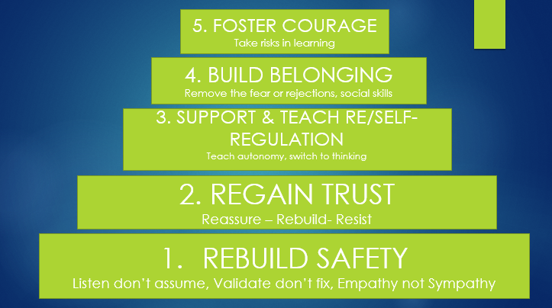

The following steps must be implemented when addressing behavioural needs across the school and must be done in order.

**Positive teacher-pupil relationships**

Positive teacher-pupil relationships are key to combatting unacceptable behaviour. The school will focus heavily on forming positive relationships based on predictability, fairness and trust to allow teachers to understand their pupils and create a strong foundation from which behavioural change can take place.

**Strategies to Develop Strong Relationships & Manage Behaviour**

**Attends Language**

All staff praise children for the process, habit, action or effort not the outcome, avoiding generic praise – good girl/boy. This ensures that all children regardless of ability or need feel like they can achieve. Children are supported in understanding that effort is recognised, acknowledging effort and building trust. Teachers convey expectations to the children in a calm working environment where they are most receptive in order to develop and nurture positive behaviour for learning as well as our school values: resilience, courage, determination etc. This approach is effective in nurturing emotion and self-esteem.

*“I can see how you have ….” “I have noticed…”*

**Lowest Emotional Response**

Teachers are encouraged to always deal with any inappropriate behaviour with the lowest emotional response, this ensures minimal attention is gained for negative behaviour as this type of attention is not nurturing and has a negative impact on self-esteem. A zero tolerance approach will always be adopted with choice at every point for the child ie “*you have a choice to finish your work in lesson or complete it at lunch.”* Giving children the choice enables them to take some responsibility for both their behaviour as well as a possible consequence.

**Take them Back to Learning**

Within lesson children may begin to lose focus and concentrate, which can result in disruption, sometimes a question such as “*you ok?”* or “*what should you be doing now?” “Where should you be?”* is enough to re-engage a child and prevent an escalation.

**Secondary Conversation**

Children can often draw an adult into a secondary conversation, it is important that teachers and TA’s remain with the current issue, putting a stop to further conversation or discussion which takes the child away from learning. Staff to adopt a key word ie “*Stop, Enough, End*,” said in a low, monotone voice

**Preventative measures for pupils with SEND**

Behaviour will always be considered in relation to a pupil’s SEND. If it is deemed that a pupil’s SEND has contributed to their misbehaviour, the school will consider whether it is appropriate and lawful to implement consequences for the pupil.

Where a pupil is identified as having SEND, the graduate approach will be used to assess, plan, deliver and review the impact of support being provided.

The school will aim to anticipate likely triggers of misbehaviour for all pupils including SEND and put in place support to prevent these, taking into account the specific circumstances and requirements of the pupil concerned. Measures the school will implement where appropriate include, but are not limited to, the following:

* Short, planned movement breaks for a pupil whose SEND means they find it difficult to sit still for long
* Ensuring a pupil with visual or hearing impairment is seated in sight of the teacher
* Adjusting uniform requirements for a pupil with sensory issues or relevant medical condition
* Training for staff in understanding autism and other conditions

**De-escalation strategies**

Where negative behaviour is present, staff members will implement de-escalation strategies to diffuse the situation. This will include:

* Appearing calm and using a modulated, low tone of voice
* Never say *“please*”, always say *“thank you*”, this gives the chd the expectation and trust that they will make the right choice.
* Describe the reality and validate their feelings – *“I can see you are upset/angry etc!”*
* Using simple, direct functional language and after a request walk away, again there is an expectation and trust that they will make the right choice
* Avoiding being defensive, e.g. if comments or insults are directed at the staff member.
* Providing adequate personal space and not blocking a pupil’s escape route.
* Showing open, accepting body language, e.g. not standing with their arms crossed.
* Reassuring the pupil and creating an outcome goal.
* Identifying any points of agreement to build a rapport.
* Offering the pupil a face-saving route out of confrontation, e.g. a choice
* Rephrasing requests made up of negative words with positive phrases, e.g. “if you don’t return to your seat, I won’t help you with your work” becomes “if you return to your seat, I can help you with your work”.

**Physical intervention**

In line with the school’s safeguarding policy staff have the legal right to use reasonable force to prevent pupils from committing an offence, injuring themselves or others, or damaging school property, and to maintain good order and discipline in the classroom.

Physical restraint will only be used as a last resort and as a method of restraint. Staff members will use their professional judgement of the incident to decide whether physical intervention is necessary. The situations in which physical restraint may be appropriate are detailed in the Physical Intervention Policy. Wherever possible, staff will ensure that a second member of staff is present to witness the physical intervention used.

After an instance of physical intervention, the pupil will be immediately taken to the headteacher, and the pupil’s parent will be contacted. Where appropriate, the headteacher may decide to temporarily remove the pupil from the school via a suspension. Where suspension is carried out, the pupil’s parent will be asked to collect the pupil and take them home for the rest of the day – pupils will not be sent home without the school contacting their parent.

**Removal from the classroom**

The school may decide to remove pupils from the classroom for a limited period, at the instruction of a member of staff.

The pupil will be moved to a room that is:

* In an appropriate area of the school
* Stocked with appropriate resources
* Suitable to learn and refocus
* Supervised by trained members of staff

The school will only remove pupils from the classroom where absolutely necessary and for the following reasons:

* To maintain the safety of all pupils and restore stability following an unreasonably high level of disruption
* To enable disruptive pupils to be taken to a place where education can continue in a managed environment
* To allow the pupil to regain calm in a safe space

The school will ensure that pupils’ health and safety is not compromised during their time away from the classroom, and that any additional requirements, such as SEND needs, are met.

The amount of time that a pupil spends removed from the classroom will be up to the class teacher and senior leaders to decide. This could be for more than one school day. The school will ensure that the pupil is not removed from the classroom any longer than necessary.

The staff member in charge and supervising the pupil will decide what the pupil may and may not do during their time spent removed from the classroom. The headteacher will request that the pupil’s class teachers set them appropriate work to complete.

The headteacher will establish a clear process for the reintegration of a pupil who has been removed from the classroom when it is deemed appropriate and safe for them to return. Consideration will be given to what support is needed to help the pupil return and meet the expected standards of behaviour. Reintegration meetings will be held between the school, pupil and their parents, and other agencies if relevant, where necessary.

Pupils will be permitted to eat during the allocated times of the school day and may use the toilet as required.

**Reflect and Reparation**

The school will operate a restorative approach to supporting pupils with their behaviour, through the provision of time at lunch supported by senior leaders, for reflection and reparation. This is not a detention but a supportive opportunity to reflect on what has happened, discuss where children have gone wrong and how in the future situations of this nature could be managed. There will be a chance for children to think about how they can make amends and build trust again.

# Sexual abuse and harassment

The school will promote and enforce a zero-tolerance approach to all forms of sexual abuse and harassment, including sexual harassment, gender-based bullying and sexual violence. The school’s procedures for handling child-on-child sexual abuse and harassment are detailed in the Child-on-child Abuse Policy.

The school will respond promptly and appropriately to any sexual harassment complaints in line with the Child Protection and Safeguarding Policy; appropriate steps will be taken to stop the harassment and prevent any reoccurrence. Disciplinary sanctions for incidents of sexual harassment will be determined based on the nature of the case, the ages of those involved and any previous related incidents.

Where the school is responding to a report of sexual violence, the school will take immediate steps to ensure the victim and other pupils are protected. The DSL will work closely with the police, and any other agencies as required, to ensure that any action the school takes, e.g. disciplinary sanctions, will not jeopardise the police investigation.

# Smoking and controlled substances

The school will follow the procedures outlined in its Smoke-free Policy and Pupil Drug and Alcohol Policy when managing behaviour in regard to smoking and nicotine products, legal and illegal drugs, and alcohol.

In accordance with the Health Act 2006, the school is a smoke-free environment. Parents, visitors, staff and pupils will be instructed not to smoke on school grounds. Pupils will not be permitted to bring smoking materials or nicotine products to school.

The school will have a zero-tolerance policy on illegal drugs, legal highs and other controlled substances. Where incidents with pupils related to controlled substances occur, the school will follow the procedures outlined in the Pupil Drug and Alcohol Policy and Child Protection and Safeguarding Policy.

# Child on Child Abuse

**Child-on-Child abuse** is defined as abuse between children under 18 years of age.

Fulwood and Cadley has a **zero-tolerance approach to abuse**, including child-on-child abuse.

Fulwood and Cadley will refer to the specific guidance in Keeping Children Safe in Education Part five: Child on Child Sexual Violence and Sexual Harassment and Lancashire Procedures. [5.31 Peer Abuse (proceduresonline.com)](https://panlancashirescb.proceduresonline.com/chapters/p_peer_abuse.html)

All staff will be aware that child-on-child abuse can occur between pupils of any age and gender, both inside and outside of school, as well as online. All staff will be aware of the indicators of child-on-child abuse, how to identify it, and how to respond to reports. All staff will also recognise that even if no cases have been reported, this is not an indicator that child-on-child abuse is not occurring. All staff will speak to the DSL if they have any concerns about child-on-child abuse.

All staff will understand the importance of challenge inappropriate behaviour between peers and will not tolerate abuse as “banter” or “part of growing up”.

Child-on-child abuse can be manifested in many different ways, including:

* Bullying, including cyberbullying and prejudice-based or discriminatory bullying.
* Abuse in intimate personal relationships between peers.
* Physical abuse – this may include an online element which facilitates, threatens and/or encourages physical abuse.
* Sexual violence – this may include an online element which facilitates, threatens and/or encourages sexual violence.
* Sexual harassment, including online sexual harassment, which may be standalone or part of a broader pattern of abuse.
* Causing someone to engage in sexual activity without consent.
* The consensual and non-consensual sharing of nude and semi-nude images and/or videos.
* Upskirting.
* Initiation and hazing-type violence and rituals, which can include activities involving harassment, abuse or humiliation used as a way of initiating a person into a group, and may also include an online element.

All staff will be clear as to the school’s policy and procedures regarding child-on-child abuse and the role they have to play in preventing it and responding where they believe a child may be at risk from it.

All staff will be made aware of the heightened vulnerability of pupils with SEND, who evidence suggests are more likely to be abused than their peers. Staff will not assume that possible indicators of abuse relate to the pupil’s SEND and will always explore indicators further.

All staff will be made aware of the heightened vulnerability of LGBTQ+ pupils, who evidence suggests are also more likely to be targeted by their peers. In some cases, pupils who are perceived to be LGBTQ+, regardless of whether they are LGBTQ+, can be just as vulnerable to abuse as LGBTQ+ pupils. The school’s response to sexual violence and sexual harassment between pupils of the same sex will be equally as robust as it is for incidents between children of the opposite sex.

Pupils will be made aware of how to raise concerns or make a report and how any reports will be handled. This includes the process for reporting concerns about friends or peers. Pupils will also be reassured that they will be taken seriously, be supported, and kept safe. This process will be continually reviewed by the DSL.

The school’s procedures for managing allegations of child-on-child abuse are outlined in the School Behaviour Policy. Staff will follow these procedures, as well as the procedures outlined in the school’s Anti-Bullying Policy and Exclusion Policy, where relevant.

Fulwood and Cadley DSL’s will consider:

* the wishes of the victim in terms of how they want to proceed
* the nature of the alleged incident
* the ages of the children involved
* the development stages of the children involved
* any power imbalance between the children
* is the incident a one-off or a sustained pattern of abuse
* are there ongoing risks to the victim, other children, school or college staff
* contextual safeguarding issues.

**Following a report of sexual violence, the designated safeguarding lead (or deputy) will make an immediate risk and needs assessment, considering**:

* the victim
* the alleged perpetrator
* all other children (and if appropriate adult students and staff)
* Risk assessments will be recorded and kept under review as a minimum termly
* Refer toGuidance in Keeping Children Safe in Education Sept 2022, Part 5.

# Prohibited items, searching pupils and confiscation

Headteachers and staff authorised by them will have a statutory power to search pupils or their possessions, without consent, where they have reasonable grounds for suspecting that the pupil may have a prohibited item. Authorised members of staff will be permitted to use reasonable force when conducting a search without consent for the prohibited items listed below, in line with the school’s Physical Intervention Policy. The prohibited items where reasonable force may be used are:

* Knives and weapons.
* Alcohol.
* Illegal drugs.
* Stolen items.
* Tobacco and cigarette papers.
* Fireworks.
* Pornographic images.
* Any article that the member of staff reasonably suspects has been, or is likely to be, used:
  + To commit an offence; or
  + To cause personal injury to any person, including the pupil themselves; or
  + To damage the property of any person, including the pupil themselves.

The school will also identify the following as prohibited items which may be searched for by authorised staff without consent if necessary; however, reasonable force will not be used under any circumstances:

* **E-cigarettes and vapes**
* **Lighters**
* **Aerosols**
* **Legal highs/psychoactive substances**
* **Energy drinks**

All members of staff can use their power to search without consent for any of the items listed above. Staff will follow the provisions outlined in the school’s Searching, Screening and Confiscation Policy when conducting searches and confiscating items.

# Effective classroom management

Well-managed classrooms are paramount to preventing disruptive and unacceptable behaviour. Effective classroom management will allow staff to:

* Start the year with clear sets of expectations, rules and routines that are understood by all pupils within a Class Charter, signed by all class members including staff
* Establish agreed rewards and positive reinforcements.
* Establish consequences for misbehaviour.
* Establish clear responses for handling behavioural problems.
* Encourage respect and development of positive relationships.
* Make effective use of the physical space available.
* Have well-planned lessons with a range of activities to engage all pupils regardless of need.

Subject to reasonable adjustments, e.g. those made for pupils whose SEND may affect their behaviour, pupils will be expected to follow the school Pupil Code of Conduct, which requires pupils to:

* Conduct themselves around the school premises in a safe, sensible and respectful manner.
* Arrive to lessons on time and fully prepared.
* Follow reasonable instructions given by staff.
* Behave in a respectful and polite manner towards all staff and pupils.
* Show respect for the opinions and beliefs of others.
* Complete classwork as requested.
* Hand in homework at the time requested.
* Report unacceptable behaviour.
* Show respect for the school environment.
* Always conduct themselves with Courage and Kindness

**Classroom rules and routines**

The school will have an established set of clear, comprehensive and enforceable classroom rules which define what is acceptable behaviour and what the consequences are if rules are not adhered to. Attention is given to how rules are worded, such as the use of positive language rather than negative, e.g. “act respectfully towards your peers and teachers”, rather than “do not act disrespectfully towards your peers and teachers”.

The school will also have an established set of classroom routines to help pupils work well, in the understanding that behavioural problems can arise due to the lack of a consistent routine. This includes teachers ensuring that before lessons begin, they have the full attention of all pupils, then explaining the task clearly so all pupils understand what they are supposed to be doing.

The headteacher will ensure all teachers understand classroom rules and routines and how to enforce them, including any sanctions for not following the rules.

Teachers will support pupils to understand and follow classroom rules and routines. Teachers will inform pupils of classroom rules and routines at the beginning of the academic year and revisit these daily. Where appropriate, teachers will explain the rationale behind the rules and routines to help pupils understand why they are needed, and will model rules and routines to ensure pupils understand them. Teachers will also explain clearly to pupils what will happen if they breach any classroom rules to ensure pupils are aware of the sanctions that may be imposed.

To support pupils’ continued awareness and understanding of classroom rules and routines, teachers will reinforce them in a range of ways, e.g. placing posters of the rules on classroom walls and providing regular verbal reminders of the routines. Teachers will also ensure that classroom rules and routines remain consistent and are practised throughout the year to create a more productive and enjoyable environment.

At the beginning of the school year, once the classroom rules have been devised, pupils will be provided with a classroom rules agreement which they are required to read and sign. All rules outlined in the classroom rules agreement are applicable to pupils’ behaviour elsewhere on the school premises and outside of the school – teachers will ensure that pupils understand this.

**The classroom environment**

The school understands that a well-structured classroom environment is paramount to preventing poor behaviour. This includes the teacher positioning themselves effectively within the classroom, e.g. wherever possible, teachers avoid standing with their backs to pupils and ensure they have full view of the room at all times.

Teachers will employ strategic seating arrangements to prevent inappropriate behaviour and enable it to be noticed early, such as:

* Seating those who frequently model poor behaviour closest to, and facing, the teacher.
* Seating those who frequently model poor behaviour away from each other.
* Ensuring the teacher can see pupils’ faces, that pupils can see one another, and that they can see the board.
* Ensuring the teacher can move around the room so that behaviour can be monitored effectively.
* Anxious/hyper aroused children must not sit with their back to the rest of the class, but be seated with their back to the wall facing others. This will reduce stress and support self-regulation

**Praise and rewards**

The school will recognise that praise is key to making pupils feel valued and ensuring that their work and efforts are celebrated. When giving praise, teachers will ensure:

* Use Attends Language – process and effort not outcome.
* Not general ie good boy/girl!
* The praise is given immediately following the desired behaviour.
* The way in which the praise is given is varied.
* Perseverance and independence are encouraged.
* Praise is only given when a pupil’s efforts, work or behaviour need to be recognised, rather than continuously without reason.
* The praise given is always sincere and is not followed with immediate criticism.

Whilst it is important to receive praise from teachers, the school understands that peer praise is also effective for creating a positive, fun and supportive environment. Teachers will encourage pupils to praise one another, and praise another pupil to the teacher, if they see them modelling good behaviour.

As with praise, the school understands that providing rewards after certain behaviour means that pupils are more likely to model the same behaviour again. For rewards to be effective, the school recognises that they need to be:

* **Immediate** – immediately rewarded following good behaviour.
* **Consistent** – consistently rewarded to maintain the behaviour.
* **Achievable** – keeping rewards achievable to maintain attention and motivation.
* **Fair** – making sure all pupils are fairly rewarded.

Rewards for good behaviour will include, but are not limited to:

* Verbal praise
* Communicating praise to parents
* Certificates, prize ceremonies, postcards home and special assemblies
* Positions of responsibility, e.g. being entrusted with a particular project
* Trips and activities for a whole-class or year group

**Whole school house point system** - All children belong to a designated house: Minotaur, Unicorn, Pegasus, Phoenix, Chimera and Griffin linked to our school values. Pupils can receive house points for any positive behaviours around school and these are recorded in classes and collated weekly. At the end of each week the running total is shared with the children during celebration assembly and at the end of two weeks the winning house is allowed to attend school on the following Friday in non-uniform.

# Behaviour outside of school premises

Pupils at the school must agree to represent the school in a positive manner. The guidance laid out in the Pupil Code of Conduct will apply both inside school and out in the wider community, particularly if the pupil is dressed in school uniform.

Staff can discipline pupils for misbehaviour outside of the school premises, including conduct online, when the pupil is:

* Wearing school uniform.
* Travelling to or from school.
* Taking part in any school-related activity.
* In any way identifiable as being a pupil at the school.

Staff may also discipline pupils for misbehaviour outside the school premises, including conduct online, that:

* Could negatively affect the reputation of the school.
* Could pose a threat to another pupil, a member of staff at the school, or a member of the public.
* Could have repercussions for the orderly running of the school.

Any bullying witnessed outside of the school premises and reported to the school will be dealt with in accordance with the Anti-bullying Policy.

The school will impose the same consequences for bullying incidents and non-criminal misbehaviour witnessed or reported outside of the school premises as would be imposed for the same behaviour conducted on school premises. In all cases of unacceptable behaviour outside of the school premises, staff will only impose sanctions once the pupil has returned to the school premises or when under the supervision of a member of staff.

Complaints from members of the public about the behaviour of pupils from the school are taken very seriously and will be dealt with in accordance with the Complaints Procedures Policy.

# Data collection and behaviour evaluation

The school will collect data from the following sources:

* Behaviour incident data, including on removal from the classroom
* Attendance, permanent exclusion and suspension data
* Use of pupil support units, off-site directions and managed moves
* Incidents of searching, screening and confiscation
* Anonymous surveys for staff, pupils, governors, and other stakeholders on their perceptions and experiences of the school behaviour culture

The data will be monitored and objectively analysed termly by the headteacher and the SLT, with information shared with the Governing body. Attempts will be made to identify possible factors contributing to the behaviour, any system problems or inadequacies with existing support. The data will also be analysed considering the protected characteristics under the Equality Act 2010 to inform school policies and practice.

# Monitoring and review

This policy will be reviewed by the headteacher and senior mental health lead on an annual basis; they will make any necessary changes and communicate these to all members of staff and relevant stakeholders.

This policy will be made available for Ofsted inspections and reviews by the lead inspector, upon request.

The next scheduled review date for this policy is Oct 2024

Appendix A

**List of Consequences, which may be used in response to inappropriate behaviour.**

|  |  |
| --- | --- |
| **Examples of Inappropriate Behaviour** | **Logical Consequences.** |
| Disrupting learning/ Wasting time in lessons | Dealt with by the class teacher  Removed from the class display  Move within the classroom, loss of playtime possible time out to another class. |
| Swearing | Class Teacher / Key stage leader – dependent on situation  Removed from the class display  Loss of playtime, privileges. |
| Spoiling other children’s playtime | Staff on duty/Class Teacher  Removed from the class display  Loss of playtime  Possible referral to pastoral team if persistent |
| Talking/ interrupting teacher when talking | Dealt with by class teacher  Removed from the class display  Move within the classroom, loss of playtime, |
| Verbal violence/ Physical violence | Class Teacher / Key Stage Leader/SLT (dependent on situation)  Removed from the class display  loss of privileges club, playtimes etc,  notify parents |
| Refusing to work | Class Teacher  Removed from the class display  work to be completed in their break/lunch time  Inform parents if necessary |
| Stealing | Refer to DHT/ HT  Inform parents  Support from pastoral team |
| Lying | Class Teacher  Removed from the class display  Loss of playtime to reflect, possible referral to pastoral team |
| Disrespect to adults in school | Class Teacher / Refer to Key Stage Leader  Removed from the class display  Loss of privileges club, playtimes |
| Bullying of any kind | Refer to senior leadership team (Deputy Head/ Head Teacher)  Removed from class, parents informed, incident formally recorded, loss of privileges club, playtimes |
| Racial comments | Refer to senior leadership team (Deputy Head/ Head Teacher)  Removed from class, parents informed, incident formally recorded, loss of privileges club, playtimes |

Appendix B

Behaviour Reflection Form

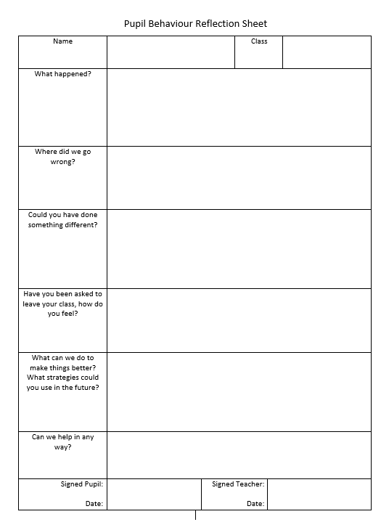

Appendix C

Pattern Mapping Form

|  |  |  |  |  |  |  |  |  |  |  |  |  |  |  |
| --- | --- | --- | --- | --- | --- | --- | --- | --- | --- | --- | --- | --- | --- | --- |
| **Target’s for** |  | | | | | | | | * **W/C: ……………………………………** | | | | | |
|  | **Registration** | | **Phonics** | | **Morning learning** | | **Lunch** | | **Afternoon** | | **End of the day** | | |
|  | Teacher | Child | Teacher | Child | Teacher | Child | Teacher | Child | Teacher | Child | Teacher | Child |
| **Monday** |  |  |  |  |  |  |  |  |  |  |  |  |
| **Tuesday** |  |  |  |  |  |  |  |  |  |  |  |  |
| **Wednesday** |  |  |  |  |  |  |  |  |  |  |  |  |
| **Thursday** |  |  |  |  |  |  |  |  |  |  |  |  |
| **Friday** |  |  |  |  |  |  |  |  |  |  |  |  |
| **Don’t forget to see Mrs Gill/Mrs France on Friday to show her how well you are doing.**  **Signed: ………………………………………..** | | | | | | | | | | | | | |

Appendix D

SDQ Teacher

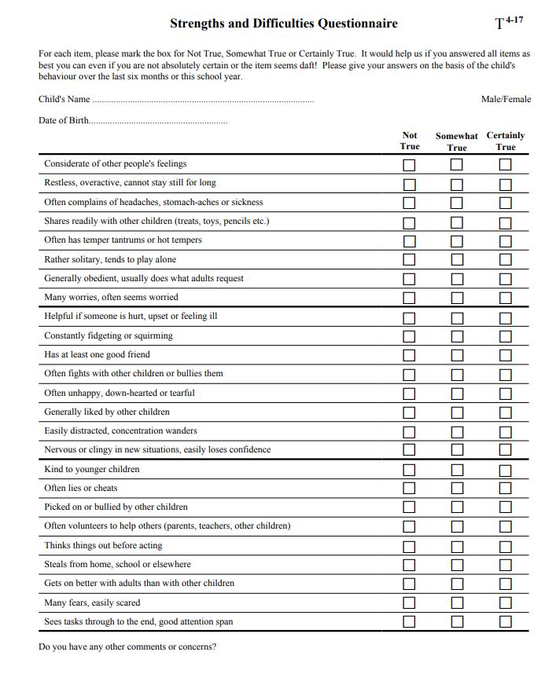

SDQ Parent

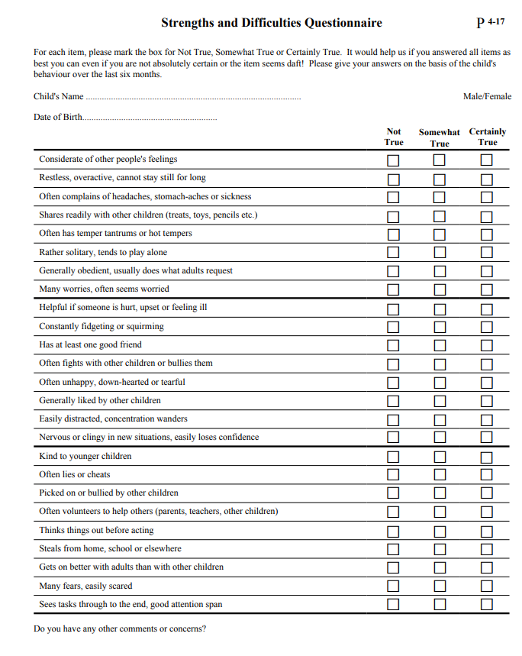

Appendix E

Internal Referral Form

Fulwood and Cadley Primary School

*“Wish it, Dream it, Do it. Be Unique.”*

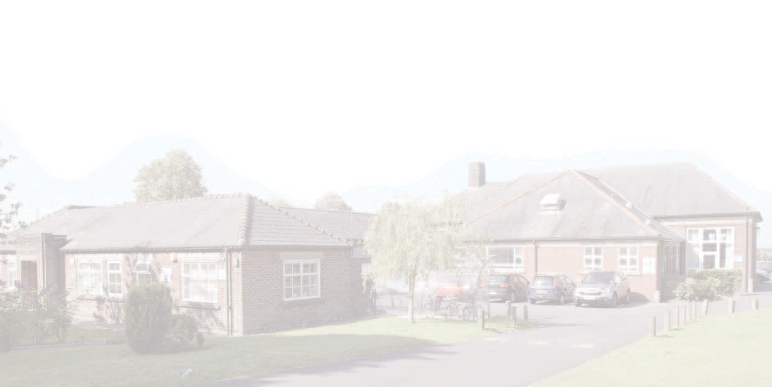**Internal Request for Pastoral Support**

|  |  |  |  |
| --- | --- | --- | --- |
| Date of Request |  | Staff Member |  |
| Name of Child |  | Class |  |
| Reason for Request |  | | |
| Effect on Progress in Learning |  | | |
| Actions already taken to address need |  | | |
| Types of Support Required |  | | |
| Please complete this form and an SDQ and submit to  SENCO and Headteacher | | | |

Appendix E

**Behaviour incident form**

Use this form to help structure your log on C-Poms, doesn’t have to be uploaded, can just be recorded as an incident.

|  |  |  |  |
| --- | --- | --- | --- |
| **Name of pupil** |  | **Year group** |  |
| **Date** |  | **Time** |  |
| **Location of observation** |  | **Name of staff member** |  |
| **Before the incident: what led to the behaviour?** | | | |
|  | | | |
| **During the incident: what did the pupil do?** | | | |
|  | | | |
| **After the incident: what were the consequences of this behaviour?** | | | |
|  | | | |
| **Additional comments** | | | |
|  | | | |